**HW21-Find pitfalls in the Project**

**Long Methods:**

**Location:** loadEmployees() method in EmployeeManager

**Problem:** Method too long Solution: Split into smaller methods: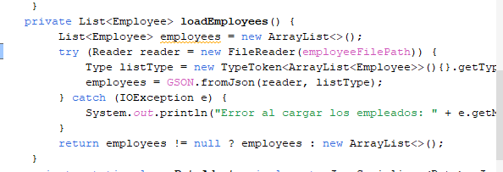

**Type embedded in names:**

**Problem:**

**In some places like EmployeeFile, it might be better to change it to EmployeeFilePath to avoid having the type (file) in the name.**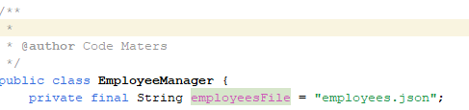

**Oddball Solution**:

**Problem:**

In the Validations class, the isValidId method returns matcher.matches() twice within an if that adds no actual value. This logic is unnecessarily confusing.

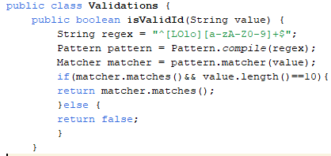

**Conditional Complexity:**

**Location:** Deserialize method in DateAdapter

**Problem:** Complex conditional structure

**Solution:** Use a stream to simplify: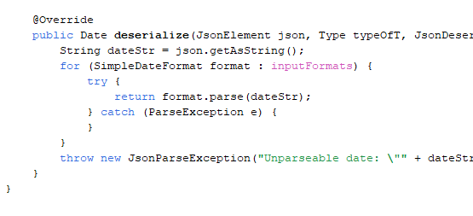

**Non-descriptive variable names:**

**Explanation:**

Variables like GSON, employees, aIessPercentage, and aOvertimeHourIncrease are not descriptive enough.

**Possible solution:**

They should have clearer names that indicate their exact purpose, such as gsonInstance or employeeList or employees.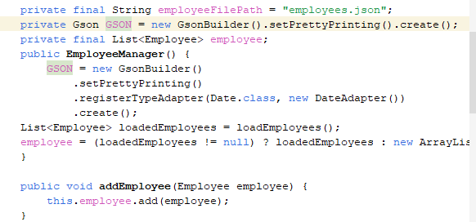

Second;

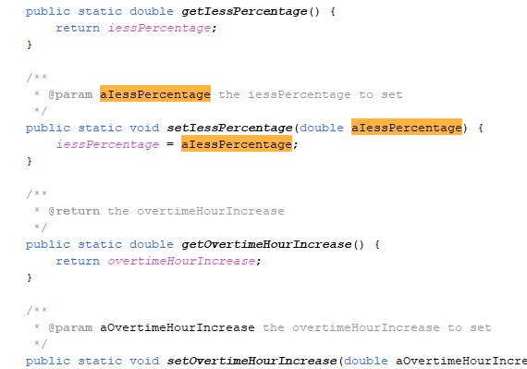

**Dead Code**:

**Explanation:**

Use useless code that is not used in the same code

**Possible solution:**

Remove getOIntInput function as it has no functionality

